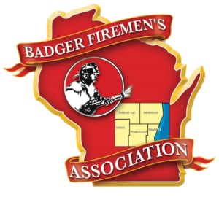
REMEMBERING OUR BROTHERS AND SISTERS
Retired Captain Mark Scharrer of the Allenton Fire Department
Retired Assistant Chief Leslie “Les” Gessner of the Beechwood Fire Department
Retired Firefighter Roger Kumrow of the Beechwood Fire Department
Retired EMT Carol Oestreich of the Campbellsport Fire Department
First Responder Peter Krueger of the Cedarburg Fire Department
Firefighter, First Responder Robert Heck age of the Cedarburg Fire Department
Kenneth Doughman of the Cedarburg Fire Department
Retired Firefighter Alvin Giese of the Grafton Fire Department
Retired Firefighter and EMT Morris “Morrie” Belger of the Kewaskum Fire Department
Retired Firefighter Roger “Butch” Schmitt of the Kewaskum Volunteer Fire Department;
Retired firefighter Daniel Schwab of the Random Lake Fire Department
Retired Captain Fred Wolf of the Richfield Fire Company
Retired Chief Glenn Dickmann of the Saukville Fire Department
Retired EMT Mary Jane Murphy of the Saukville Fire Department
Retired EMT Sharon Kirsch of the Saukville Fire Department
Retired firefighter and EMT, Glenn Zimmermann of the Silver Creek & Random Lake Fire Departments
Retired Battalion Chief Arlyn Sarauer of the West Bend Fire Department
Honoring those that have dedicated their lives to help others.

